HOMEOPATHIC CASE TAKING FORM

Dr. Dwivedi’s





Dr. A.K. Dwivedi

Dr. Vinita Dwivedi

(B.H.M.S., M.D.)

(B.H.M.S., D.Ph.)

Dr. Dwivedi’s

Khushi Clinic

&
Homeopathy Research Center

! " # $$% %&


' & ( )* $+$ $&

, ( -


All information given is kept confidential

Dr. Dwivedi’s

PLEASE READ THIS FIRST BEFORE FILLING THIS FORM. .

HOMOEOPATHIC MEDICINE IS MAINLY SELECTED ON THE SYMPTOMS YOU GIVE US.

If we are to make a successful prescription, we must know all the details of your sickness. We must also understand all the features that belong to you as an individual. This includes your reactions to various factors, your past and family history and your mental makeup. This information enables us to select the remedy that removes your sickness. The medicine also makes you well as a whole person. In order find all about you, we shall be asking you many questions. Each one of these questions has a definite meaning and significance for us. There is not a single question that is useless. Even something that you may think is not connected with your trouble may be the most important factor in deciding the correct homoeopathic medicine. That is why you must be free and frank and give us the fullest possible information on each point. Please read each question carefully, think, and if necessary, consult someone close to you and then answer completely. Do not keep anything back. Remember, whatever you tell us will remain absolutely confidential.

THIS QUESTIONNAIRE HAS SEVERAL PARTS:

- About your past illnesses. Please take time to answer this part with the help of your family members before coming to us.

- History of your present illness.

- About all the parts of your body.

- Deals with the factors that affect your health. Please think carefully about each of the factors mentioned and write what specific effects they have on you.

- About your mental state and your emotional nature. Please write in this part about your situation in life and about all the things that are bothering you. Be totally frank and open.

- About your sleep and dreams.

- For children or how you were as a child.

- In this part you are given instructions on how to report each of your complaints. Read the instructions first. Then make a list of your complaints and describe each of them according to the instructions.

Founder of Homeopathy
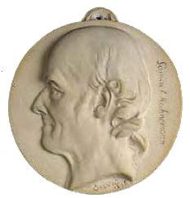

Christian Friedrich Samuel Hahnemann

(10 April 1755 – 2 July 1843)

All information given is kept confidential

 |  | Confidential |  | DATE
 |  | NAME
 |  | AGE |  | SEX
 |  | MARITAL STATUS
 |  | FATHER’/HUSBAND’S
 |  | NAME
 |  | TELEPHONE
 |  | WORK PLACE/JOB
 |  | E-MAIL
 |  | ADDRESS
 |  | DIAGNOSIS
 |  | REFFERD BY

Any other Information to share

All information given is kept confidential
Please describe your complaints. Giving Details on when it began, how it has progressed.
Please mention factors that increase or decrease discomforts.

RECORD PROBLEMS IN CHRONOLOGICAL ORDER
(Earliest in the beginning and latest at the end)

Summary of tests, evaluations done

 | Tests | Results

Please mention other therapies the patient is on, include the therapists name, from when the therapy began and changes that you have noted since.

RECORD IN CHRONOLOGICAL ORDER (Earliest in the beginning and latest at the end)

S.no | Date | Therapy ( Allopathic/Ayurvedic/Homeopathic/Others )

Please mention the names and dosage of medicine and supplements that you are on now or have taken in the past

 | Medicine | Doses/Type

All information given is kept confidential
Past History

Every disease, poisoning, drug or accident leaves its mark and remains a weak point in the system, much more than we imagine. Homeopathic treatment takes into account all the details of the past and thus removes all the weak points. Thus your body is strengthened. That is why it is necessary for us to know about all the ailments you have suffered from in the past and the treatment you have taken.

In the list below underline the names of all major illnesses so far suffered

Adenoids |  | Backache |  | Diabetes mellitus |  |  | Eczema,
Allergy. |  | Bronchitis |  | Diarrhea |  |  | Eosinophilia
Any Major Accident |  | Carbuncles |  | Diabetes insipidus |  |  | Food poisoning
Any major bleeding |  | Chicken-pox |  | Diphtheria |  |  | Fungus,
Appendix, |  | Cholera |  | Dysentery |  |  | gall bladder disease
Asthma |  | Cataract |  |  |  |  | Giddiness
 |  | Cold-Fever-Chill,
Heart trouble |  | Injury to body or head. |  | Malaria |  |  | Piles,
Herpes, |  | Jaundice |  | Malnutrition |  |  | Phimosis,
High/Low B.P |  | Kidney affection |  | Measles |  |  | Pimples, boils,
Hydrocele |  | liver, spleen disease |  | Menstrual complaints, |  |  | Pneumonia
 |  |  |  | Mumps |  |  | Prolapse of uterus
 |  |  |  |  |  |  | Prostrate trouble
Rheumatism |  | Scabies |  | Tuberculosis, |  |  | Any Other Diseases
Rickets |  | Sinusitis |  | Tonsils, |  |  | Mention it below
Ringworm, |  | Skin diseases |  | Urticaria
 |  | Septic, |  | Ulcers on any
 |  | Small-pox |  | venereal disease
 |  | Stones (kidney, gall
 |  | bladder)
 |  | Syphilis, Gonorrhea
Diseases suffered from |  | Age at | Duration |  | Whether you | Medicines & |  |  | Any other
 |  |  |  |  | completely | treatment |  |  | particulars
 |  |  |  |  | recovered | taken

Any extra remarks or information

All information given is kept confidential
List of major | Relationship |  | Alive / | Age | Diseases suffered
diseases |  |  | Dead
 | Paternal
Anemia | Grand Father
Cancer | Paternal
Diabetes | Grand Mother
Diabetes | Maternal
Insanity
Insanity | Grand Father
Arthritis
Arthritis | Maternal
Rheumatism
Rheumatism | Grand Mother
T. B. / Pleurisy
Leprosy | Father
Epilepsy / Fits
Bleeding tendency | Mother
Urticaria
Eczema | Brothers
Asthma | Sisters
Paralysis
Paralysis | Paternal
Thyroids
Thyroids | Uncle/ Aunts
Hypertension
Hypertension | Maternal
Heart trouble
Heart trouble | Uncle/Aunts
Kidney disease
Kidney disease | Cousin
Liver disease etc.
Liver disease etc. | Brother & Sister
Vitiligo
Vitiligo | Did any of your
Other Diseases | relatives have trouble
 | similar to yours
 |  | INFORMATION ABOUT SPOUSE AND CHILDREN

How is the health of your spouse? Please explain.

Mention ages of children and their condition of health

Child’s name | Age | Diseases Suffered
Male/Female

Have you had any abortions, miscarriages or still birth? What was the identified cause? (For Females)

All information given is kept confidential
PERSONAL HABBITS

Your Habits | How much?

Smoking

Snuff

Chewing tobacco

Alcohol

Tea

Sleeping Pills

Laxatives / Purgatives

Recreational Drugs

Any other

APPETITE AND THIRST

How is your appetite?

When are you hungry?

What happens if you have to remain hungry for long?

How fast do you eat?

How much thirst do you have?

Any particular times are you especially thirsty?

Do you feel any change in your taste and feeling in your mouth?

Please put one tick (  ) if you Like/ Dislike the food or if the food disagrees. Put two marks (Up), if you strongly Like / Dislike the food or if the food strongly disagrees.

 | Like | Dislike | Disagrees |  | Like | Dislike | Disagrees
Bitter |  |  |  | Eggs
Salt |  |  |  | Spicy food
Sweet |  |  |  | Meat
Sour |  |  |  | Fish
Bread |  |  |  | Cabbage
Butter |  |  |  | Onions
Fats |  |  |  | Warm food / drink
Milk |  |  |  | Cold food / drink
Coffee |  |  |  | Fruits
Mud / Chalk |  |  |  | Anything else

All information given is kept confidential
STOOL

Do you have any problem regarding your stools?

When and how many times a day you pass stools?

When is it urgent?

Do you have any problem about bowel movements?

Do you have to strain for stool? Even if soft?

Do you have belching or passing gas? Describe its character.

How do you feel after passing gas up or down?

URINATION & URINE

Any problem about urine?

Any strong smell? Like what?

Do you have any trouble before, during and after passing urine?

Any difficulty about the flow? Slow to start, interrupted, feeble, dribbling etc.?

Any involuntary urination? When?

SWEAT / PERSPIRATION - FEVER - CHILL

How much do you sweat?

Where and on what part do you sweat most?

Do you perspire on the palms or soles?

Is the sweat warm, cold, clammy, sticky, musty, greasy, stiffens the linen etc.?

What is the smell like? E.g. foul, pungent, sour, urinous.

What color does it stain the clothing?

Is the stain easy to wash off or difficult?

Any symptoms after sweating?

When do you get fever or chill?

What brings it on?

Do you experience any sense of heat or cold in

any part of your body at any particular time ?

Do you have burning or heat in your palms or soles ?

CHEST - HEAT - COLD - COUGH

Do you catch cold often? If so, how?

Describe the symptoms, nature of discharge etc.

Is there any trouble with your CHEST or HEART?

Is there any trouble with your voice or speech?

Is there any difficulty in breathing?

Do you have cough?

Is it more at any particular time?

All information given is kept confidential
SEXUAL SPHERE (GENERAL)

Any excessive indulgence in sex in past and present?

Any effect on your health?

How do you feel after sexual intercourse?

Any particular feeling or symptoms appear before, during or after sexual intercourse?

Do you suffer from any sexual disturbance?

Any habit like (masturbation etc.) in past as well as present? How often?

Any homosexual inclination?

Did you suffer from any sexually transmitted disease?

Syphilis? Gonorrhea? Herpes? HIV?

Did you have increased desire or decreased desire for sex?

What is the method you use for family planning (contraception)?

FOR MEN

Any difficulty in erection?

Wanted erection? Unwanted erection?

Weak erection? Failing erection? Describe.

Any other trouble in sex? Describe in details.

FOR WOMEN

Menses: How are the periods; regular or irregular?

At what age did you start?

Was there any trouble then?

Mention interval between two periods.

Mention number of days of flow.

Menstrual flow: Is there any change now in quantity,

Color, smell or consistency?

Are the stains difficult to wash?

Have you noticed any variation in quality?

and quantity of flow during menses ? How and when?

Do you suffer in any way before, during or after menses? If so, describe:

What symptoms did you suffer during menopause?

Do you feel internal parts coming down?

Is there any white discharge?

If so, mention the nature, color, consistency and smell of discharge.

When and under what circumstances is it more or less?

Has the discharge any relation to menses?

What is the effect of this discharge on your general feeling? Or any of your symptoms?

Any itching, excoriation etc. due to discharge?

Any trouble with breasts?

All information given is kept confidential
ANY COMPLAINTS ABOUT:

VERTIGO - Do you have giddiness - vertigo?

Faintness: Do you ever feel faint?

HEAD: Do you get headaches?

EYES & VISION:

EARS & Sense of hearing:

NOSE & Sense of smell:

FACE & Facial expression:

MOUTH & Sense of taste:

About LIPS, MOUTH, TONGUE etc.:

TEETH, GUMS, e.g. carious teeth, bleeding/swollen gums.

LIPS: Cracked, peeling of skin etc.

THROAT (including tonsils):

Any difficulty in swallowing?

Do you have any trouble in your BACK, LIMBS OR JOINTS?

Describe in detail:

If you have pains, do they shift?

In what direction do they extend?

Is there any abnormality, swelling, numbness, paralysis etc. in any part of the body?

All information given is kept confidential
FACTORS THAT AFFECT YOU

Below are the list of things that you are exposed to each of these factors may affect you in a particular way. Please write in what way you are affected by each of the following. Do you feel worse or better in any way from each of the factors? In what way do they affect you? For instance take the factor “sun”. Suppose by going in the sun you get a headache then write “Headache” opposite to “Sun”. Take another example if in hot weather you feel uneasy, and then write “Uneasy” opposite to “Hot Weather” in the column. In this way write the effect of each factor on you. Especially write the effect each factor has on your main complaints. For instance if your main complaint is Asthma and this is worse when lying on the back then opposite to “lying on the back” write “Asthma becomes worse”. Sometimes one factor may make you feel worse in some respect, and better in some other respect. For instance cold air may cause headache but make you feel better in general. If this is so, please mention this difference clearly. This section is most important. Do not go through it hurriedly. Think carefully about the effect of each factor before you write.

 | Effect |  |  | Effect |  | Effect
Hot weather |  |  | Walking |  | Noise
Cold weather |  |  | Running |  | Sudden Noise
Rainy weather |  |  | Climbing stairs |  | Music
CloudyWeather |  |  | Going downstairs |  | Light
Change of season |  |  | Riding in bus, car |  | Strong smells
Thunder storm |  |  | Lying
Covering |  |  | Lying on back |  | Before Urine
Warm bath |  |  | Lying on left side |  | During Urine
Sun |  |  | Lying on right side |  | After Urine
Drinking |  |  | Lying with head low |  | Before Menses
Sitting |  |  | After sexual |  | During Menses
 |  |  | intercourse
Sitting erect |  |  | Dust |  | After Menses
Standing |  |  | Smoke |  | Before
 |  |  |  |  | important
 |  |  |  |  | meeting
Looking up |  |  | Touch |  | Before exams
Looking down |  |  | Pressure |  | When angry
Looking from high |  |  | Massage |  | When worried
places
Looking from |  |  | Tight Clothes |  | When sad
moving object
When Fasting |  |  | After Sweating |  | After Weeping
After eating |  |  | In constipation |  | Consolation /
 |  |  |  |  | Sympathy
In a crowd |  |  | Before Sleep |  | Over eating
In a closed room |  |  | During Sleep |  | Working in
 |  |  |  |  | water
When thinking of |  |  | After Sleep |  | Fanning
illness
Full Moon / New |  |  | After afternoon nap |  | Hanging the
Moon |  |  |  |  | limbs
Morning |  |  | Loss of sleep |  | Arms raising
Afternoon |  |  | Before stools |  | Near Sea
Evening |  |  | During stools |  | Shaving
Night |  |  | After stools |  | Stretching
Bathing |  |  | Coughing |  | Swallowing
Draft air |  |  | Sneezing |  | Listening to
 |  |  |  |  | others talk
Biting or chewing |  |  | Laughing |  | Moonlight
Blowing Nose |  |  | Talking |  | Moving the
 |  |  |  |  | eyes
 |  | All information given is kept confidential

When alone |  | Reading |  | Opening the
 |  |  |  | eyes
In company |  | Writing |  | Closing the
 |  |  |  | eyes
Physical exertion |  | Stooping |  | Getting feet
 |  |  |  | wet
Belching |  | Passing gas |  | Brushing teeth
Vomiting |  | After hair cut |  | Opening the
 |  |  |  | mouth
Yawning |  | Combing hair |  | Smoking

Any other factors which Effects you

All information given is kept confidential
MIND

It is now universally acknowledged that your mind has tremendous influence on our body. For giving proper treatment it is absolutely necessary for us to understand your emotional and intellectual nature. We can thus treat you as a whole. In order to understand you we will be asking certain questions. Answer them freely, carefully and completely. This information will help us much in giving you the correct remedy. Also such a remedy will help improve your mental makeup.

Answer freely. Answer frankly. Answer completely.

Are you anxious? About which matters?

Are you fearful of anything such as animals, people, being alone, darkness, death, disease, robbers, sudden noises, thunder, of the future, of something unknown, high places, etc.?

Are you doubtful or suspicious? Of what?

What are you jealous about?

Of whom? From what symptoms do you suffer when jealousy?

In which matter are you impatient? Hurried?

How long do you remember hurts caused to you by others?

How much revengeful are you?

What are you proud of? Does your pride get easily hurt?

Depress, Brooding, etc.?

Do you ever become suicidal? When?

If so in what manner do you contemplate to end your life?

Even then, are you afraid of dying?

When are you cheerful?

Any unwanted thoughts any time? What are they?

Have you any imaginary sensations or fears ?

Do you hear voices, or that you are called, or anything else in this line keeps on occurring in your mind

All information given is kept confidential
unduly ?

How is your memory ? For what is it poor? e.g. names, places, faces, what you have read, etc.

Do you weep easily ? What makes you weep ?

How do you feel after weeping ?

How do you feel if someone offers sympathy and consolation ?

Are you easily irritated ?

What makes you angry ?

What bodily symptoms do you develop when angry ? e.g. trembling, sweating etc.

Do you like company ? Or like to remain alone ?

How seriously are you affected by disorder and uncleanliness in your surrounding ?

What are the greatest griefs that you have gone through in your life?

What are the greatest joys that you have had in life?

What activities you deeply like?

Are there any matters which you deeply dislike?

In your opinion, which aspects of your mind and moods are not agreeable to you. Inspite of your awareness and maturity, are you unable to change these aspects?

Give a clear cut picture of your situation in life and your relationship with each of your family members, friends and associates in work.

How does the future look to you?

When you are free, what thoughts come to your mind?

Are you worried or unhappy over? Any personal, domestic, economical, Social or any other condition? If so describe in detail:

All information given is kept confidential
If asked for 3 desires or wishes in life, what will you ask for?

1

2

3

S L E E P

Describe your posture in sleep, on the back, side, abdomen etc.

Are you able to sleep in any position?

In which position you can’t sleep?

During sleep do you:

Snore?

Grind teeth?

Dribble saliva?

Sweat?

Keep eyes or mouth open?

Walk? Talk? Moan? Weep?

Become restless?

Wake up with a jerk?

Describe if anything else is unusual: About your sleep: (Sleepy, Sleeplessness, etc. if so when)

How much do you cover?

Do you have to uncover any parts?

All information given is kept confidential
FOR CHILDREN
Or
YOU AS A CHILD (IN CASE OF ADULT)

Please write in detail, if the mother suffered from any physical or emotional stress during pregnancy. Also describe the dreams the mother got during pregnancy.

Please describe any other aspects you feel are striking about the child.

Describe one incident from the child’s life when he/she very upset.

Other Important details you want to share:

All information given is kept confidential
HOW TO DESCRIBE YOUR COMPLAINTS (For Patients)

In homoeopathy, prescription is based on precise details of various symptoms from which you suffer. To tell or write to a homoeopathic physician “I have a headache”, “an eruption”, or “cough”, would not be enough. If you inform him “I have headache with sharp shooting pains in the left side of the head and temple, these pains always come on when the slightest cold air strikes the head, the pains are much less when lying down and covering up the head warmly and much worse when rising up, walking about or when the head becomes cool”, then only you have given all the information required for making a good homoeopathic prescription.

The success of the prescription depends, largely, on how detailed is your description of the symptoms.

We require the following details about your symptoms.

LOCATION:
____________________________________________________________________________________

Please give the exact location of sensation, pain or eruption. Also describe where the pain or sensation spreads. Please use the figure on page below to indicate location.

SENSATION:
____________________________________________________________________________________

Express the type of sensation or the pain that you get in your own words however simple or funny it may seem. You may have a sensation that a mouse is crawling or the heart was grasped by an iron hand or you may have a pain which is cutting, burning jerking, pressing. Express the sensation or pain as it feels to you.

WHAT MAKES YOU WORSE OR BETTER:
____________________________________________________________________________________

Many factors are likely to influence your trouble. Some factors may cause the trouble to increase and some factors may relieve the trouble. A detailed list of the factors is given on pages 14 to 16. Please refer to them when describing each of your troubles and indicate which factors make the complaint better or worse.

DISCHARGES: You may have a discharge from ulcers, fistula, eruptions the skin, lungs, eyes, nose, ears, mouth, private parts, etc. Please describe your discharge under the following aspects.

- The quantity and the time or condition under which the quantity varies i.e. when it is better or worse, increases or decreases?

- The consistency; Is it thin or thick, stringy, or clotted?

- Is it like jelly, white of an egg, like water, sticky, forming a scab etc.?

- The odour, what does it remind you of?

- Does it make the parts sore, and in what way?

All information given is kept confidential
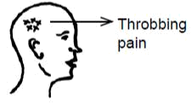
Please mark in the below figure, the locations of your trouble and write the exact sensation or type of pain you experience at those spots. For example if you have throbbing pain on the right side of you head please mark as shown
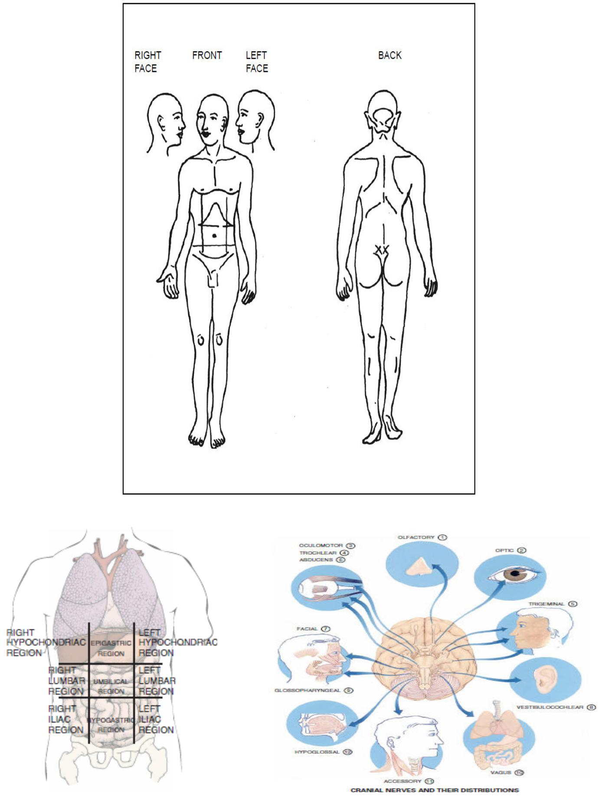

All information given is kept confidential
ANATOMICAL LANDMARKS
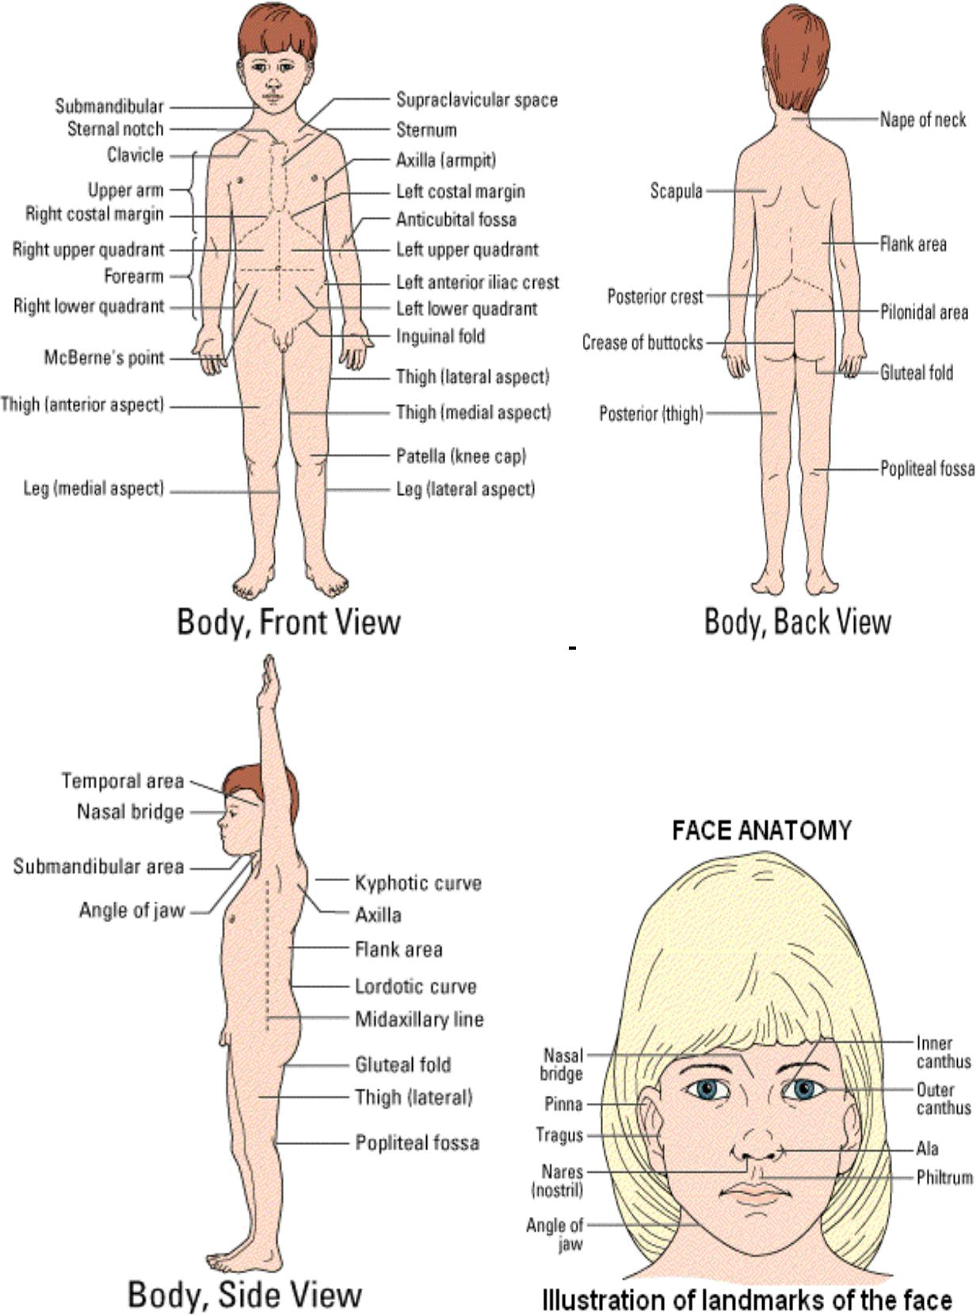

All information given is kept confidential

IN THE FOLLOWING PAGES PLEASE DESCRIBE EACH OF YOUR COMPLAINTS IN DETAIL IN THE MANNER DESCRIBED ABOVE

COMPLAINT NO. | WHERE IS THE | WHAT EXACTLY DO | WHAT ARE THE
 | TROUBLE | YOU FEEL OR HAVE | FACTORS THAT
 |  | THERE | MAKE THIS TROUBLE
 |  |  | BETTER OR WORSE

Submission Date: Patient’s signature

All information given is kept confidential

